ABES ENGINEERING COLLEGE, GHAZIABAD

DEPARTMENT OF ELECTRONICS & COMMUNICATION ENGINEERING

COURSE MATERIAL
Course Level: Undergraduate
Subject Name: Basics Electronics Engineering
Subject Code: 25EC101/201
Branch/Semester: All Branches / 1st & 2nd
Session: 2025-26

UNIT-4: Basics of Integrated Circuits

- Integrated Circuits
  - Introduction
  - Evolution from discrete components to IC
    - The Birth of the Transistor: Laying the Foundation.
    - The First Integrated Circuit: A New Era.
    - The Rise of Microprocessors: The Brain of Modern Electronics
    - Moore’s Law and Miniaturization
    - The Advent of System-on-Chip (SoC)
    - VLSI and ULSI: Pushing Integration Limits.
    - ASICs (Application-Specific Integrated Circuits)
    - ASICs (Application-Specific Integrated Circuits)
  - Moore’s Law
  - Scaling
  - Monolithic v/s Hybrid IC
  - Levels of Integration (SSI, MSI, LSI, VLSI and ULSI)
- Overview of IC fabrication techniques
  - Introduction
  - Wafer Preparation
    - Key steps in wafer preparation.
  - Oxidation
  - Photolithography.
  - Etching.
  - Doping (Diffusion and Ion implantation)
  - Deposition
  - Metallization and Packaging

3.Operational Amplifier {OP-AMP.)
3.1 Introduction
3.1 PIN configuration
3.2 Op-amp symbol
3.3 Op-amp configurations
3.4 Ideal characteristics of op-amp
3.5 Definition of Op-amp parameters (slew rate, CMRR, Offset voltage)
3.6 Closed loop configuration
3.6.1 Inverting amplifier
3.6.2 Non inverting amplifier
4. 555 Timer
4.1 Introduction
4.2 Pin configuration
4.3 Modes of timer IC 555
4.3.1 Monostable Multivibrator
4.3.2 Astable Multivibrator

- EVOLUTION FROM DISCRETE COMPONENTS TO IC
  - Introduction
Integrated circuits (ICs) have transformed electronics, enabling the development of compact, complex devices from smartphones to spacecraft. The journey from discrete transistors to today's advanced microchips are marked by groundbreaking innovations.

  - Evolution from discrete components to IC
1.2.1. The Birth of the Transistor: Laying the Foundation
The transistor was developed by John Bardeen, Walter Brattain, and William Shockley in 1947 at Bell Labs that revolutionised electronics. Transistor is a semiconductor device that is used to amplify or switch electronic signals and was a great development from vacuum tubes. Transistors offered greater reliability, smaller size, and power consumption was also low. The transistor's impact was profound, paving the path to miniaturise electronic devices and setting the stage for the invention of integrated circuits.

1.2.2. The First Integrated Circuit: A New Era
First integrated circuit was developed in 1958 by Jack Kilby and Robert Noyce at at Texas Instruments and Fairchild Semiconductor independently. These early ICs combined multiple transistors and other components onto a single silicon chip, dramatically reducing the size and cost of electronic systems. Kilby's prototype used germanium, while Noyce's version employed silicon and planar technology, which enables the production of more complex and reliable ICs.
1.2.3. The Rise of Microprocessors: The Brain of Modern Electronics
Microprocessor was introduced in the year 1970s, it is a type of IC that serves as the CPU of any computer that is capable of performing basic arithmetic and logic operations. The Intel 4004, released in 1971, was the first commercially available microprocessor. This innovation revolutionised computing, enabling the development of programmable electronic devices.
1.2.4. Moore’s Law and Miniaturization
Gorden Moore, in 1965, observed that the number of transistors on a chip doubled roughly every two years, this trend is known as Moore's Law. Continuous innovation in the semiconductor industry is driven by this law, pushing the boundaries of miniaturisation. Technological advances, including lithography and advanced materials, have facilitated the transition through various technology nodes, from micrometre to nanometer scales.
1.2.5. The Advent of System-on-Chip (SoC)
With the advent of technology, evolution of IC has resulted from simple logic gates to complex systems-on-chip. (SoC), enabling multiple functions like processing, memory, and communication onto single chip. SoCs have become indispensable in modern devices, contributing to higher performance, lesser consumption of power.
1.2.6. VLSI and ULSI: Pushing Integration Limits
Very Large-Scale Integration (VLSI) and Ultra-Large-Scale Integration (ULSI) involve integrating millions and billions of transistors onto a single chip. This level of integration has enabled powerful processors, memory chips, and other advanced semiconductor devices used in applications ranging from high-performance computing to consumer electronics.
1.2.7 ASICs (Application-Specific Integrated Circuits)
ASICs (Application-Specific Integrated Circuits) have revolutionized the world of electronics by offering various benefits over traditional ICs. ASICs are designed to perform a specific task, unlike general-purpose ICs, which can perform multiple tasks. As a result, ASICs are considered to be more efficient and faster than traditional ICs. They are widely used in various applications, including automotive, aerospace, telecommunications, and consumer electronics.
1.2.8 The Future of Integrated Circuits
With emerging technologies dedicated to revolutionise the field further. Innovations like 3D ICs, which stack multiple circuit layers, offer increased density and performance. Additionally, advanced packaging techniques such as chiplets and System-in-Package (SiP) provide greater flexibility and scalability. As environmental concerns grow, the industry is also focusing on sustainable and energy-efficient IC designs, aiming to decrease the carbon footprint of electronic devices.
  - Moore’s Law

Moore's Law is the observation that the number of transistors on a microchip doubles approximately every two years, leading to increased computing power and decreased costs. Scaling refers to the physical and economic factors that enable this miniaturization, including advances in materials and manufacturing, but these are now facing limitations like heat dissipation and quantum effects. As traditional scaling slows, the industry is shifting focus to other innovations like 3D chip stacking, multi-core processors, and AI-driven design to continue improving performance
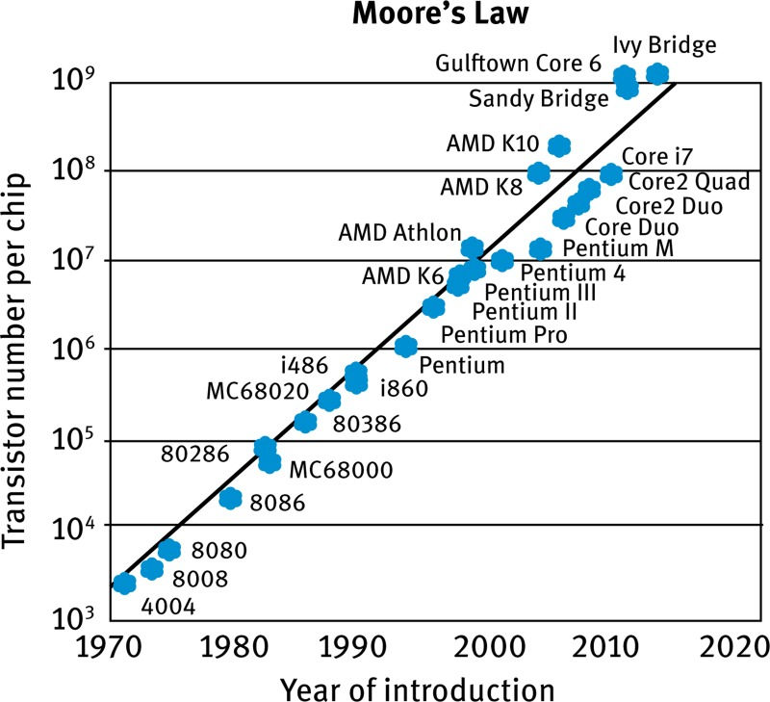
- The principle: An observation by Gordon Moore in 1965 that the number of transistors on a microchip doubles roughly every two years.
- The outcome: This trend has historically resulted in exponential increases in computing power and efficiency while relative costs decrease.
- Economic driver: It's an observation about the economics of computing, driven by the cost reduction per transistor, not a strict physical law.

  - Scaling
- Enabling advancements: Scaling refers to the process of shrinking transistors to fit more on a single chip. This has been achieved through innovations in photolithography, materials science, and nanotechnology.
- Current challenges: As transistors approach atomic sizes, physical limitations like leakage current (unwanted current flow when a transistor is off) and quantum effects become significant problems, limiting further miniaturization.
1.4.1 The future of scaling
- Shifting strategies: With the slowdown in traditional scaling, the industry is moving to new methods to increase performance.
- Architectural innovation: Examples include using more processing cores in a single chip (multi-core processors) to handle multiple tasks at once, as seen in CPUs and GPUs.
- New technologies: Other approaches include 3D chip stacking, which stacks layers of silicon on top of each other, and new materials to create more efficient transistors.
- Software and design improvements: Innovations in software, such as parallel programming models for GPUs (like CUDA), and the use of AI in chip design are also playing a crucial role in improving performance by optimizing how tasks are executed.

  - Monolithic v/s Hybrid IC

The main difference is that monolithic ICs have all components (transistors, resistors, etc.) fabricated and interconnected on a single silicon chip, while hybrid ICs combine multiple components—which can include discrete parts and separate monolithic ICs—onto a common substrate, such as a ceramic base. Monolithic ICs are smaller and cheaper for mass production, offering high reliability and speed but limited customization. Hybrid ICs are more flexible, allowing for diverse components and easier modification, making them suitable for specialized applications, though they can be larger and more expensive.

Feature | Monolithic IC | Hybrid IC
Construction | All components are fabricated on a single chip. | Multiple components are assembled on a substrate.
Components | Transistors, diodes, resistors, and capacitors are all made on the same chip. | Mix of discrete components (resistors, capacitors, inductors) and/or separate monolithic ICs.
Size | Compact and smaller. | Can be larger, depending on the number of components.
Flexibility & Customization | Limited customization options. | High flexibility and customization.
Repair/Modification | Difficult to repair or modify. | Easier to repair and modify due to modular nature.
Cost | Generally lower for mass-produced units. | Cost varies; can be higher due to complexity, but also cheaper for certain specialized applications.
Speed | High speed. | Generally lower speed compared to monolithic ICs.
Complexity | Simpler in terms of a single chip's integration. | More complex due to the integration of different technologies and components.

  - Levels of Integration (SSI, MSI, LSI, VLSI and ULSI)

The levels of integration (SSI, MSI, LSI, VLSI, ULSI) classify integrated circuits (ICs) by the number of electronic components on a single chip. SSI (Small-Scale Integration) has up to 100 components, MSI (Medium-Scale Integration) has 100 to 3,000, LSI (Large-Scale Integration) has 3,000 to 100,000, and VLSI (Very Large-Scale Integration) has 100,000 to 1,000,000. ULSI (Ultra-Large-Scale Integration) includes chips with millions and billions of transistors, though the term VLSI is often used to cover this later stage as well.
Level | Acronym | Number of components per chip
Small-Scale Integration | SSI | Up to 100
Medium-Scale Integration | MSI | 100 to 3,000
Large-Scale Integration | LSI | 3,000 to 100,000
Very Large-Scale Integration | VLSI | 100,000 to 1,000,000
Ultra-Large-Scale Integration | ULSI | Millions and billions

Applications and significance

- SSI: Used for very basic logic circuits.
- MSI: Enabled more complex logic circuits and was suitable for applications like counters, adders, and decoders.
- LSI: Revolutionized technology and made devices like the first microprocessors possible.
- VLSI: Enabled the growth of modern computing by fitting billions of transistors onto a single chip, leading to modern CPUs and memory chips.
- ULSI: Supports modern computers by integrating even larger numbers of components, essentially extending the capabilities of VLSI.

The progression from SSI to ULSI has significantly reduced the size and cost of components while increasing their power and efficiency, a trend that continues to drive modern electronics.

- OVERVIEW OF IC FABRICATION TECHNIQUES

2.1 Introduction

IC fabrication is a multi-step process that creates integrated circuits on semiconductor wafers, primarily silicon. Key techniques include wafer production, which starts with a pure silicon substrate, followed by oxidation to create insulating layers. Photolithography is then used to transfer circuit patterns from a mask to the wafer, which is selectively etched to remove material. Dopants are added through diffusion or ion implantation to create conductive regions, and finally, metallization layers are deposited to interconnect the components before the wafer is cut into individual chips and packaged.

2.2 Wafer preparation
Wafer preparation in IC fabrication begins with growing a single-crystal silicon ingot, which is then cut into thin wafers. These wafers undergo a series of mechanical and chemical processes, including grinding, slicing, lapping, etching, and a final mirror-like polishing (Chemical Mechanical Polishing) to ensure a flat, smooth, and defect-free surface ready for the fabrication of integrated circuits.

2.2.1 Key steps in wafer preparation.

- Crystal Growth: High-purity silicon is melted and a seed crystal is used to grow a large single-crystal cylinder called an ingot, using methods like the Czochralski process.
- Ingot Shaping: The ingot is ground to a uniform diameter and flattened on one side to create a reference flat for later processing.
- Slicing: A precision wire or diamond saw slices the ingot into thin, circular wafers of uniform thickness, typically a few hundred micrometers thick.
- Edge Rounding: The edges of the wafers are rounded to prevent chipping and cracking during handling.
- Lapping: This mechanical process removes saw marks and ensures the wafers are within a specific thickness tolerance.
- Etching: Chemical etching removes surface damage and contaminants left from the slicing and lapping processes, resulting in a smoother surface.
- Polishing: Chemical Mechanical Polishing (CMP) uses a slurry of chemicals and abrasives to create a mirror-like, ultra-flat, and defect-free surface essential for subsequent fabrication steps.
- Cleaning: Throughout the process, rigorous chemical and ultrasonic cleaning removes any remaining contaminants or particles.
- Inspection: The finished wafers are inspected for quality, including dimensions, flatness, and surface defects, before being packaged for transport.

2.3 Oxidation.

Oxidation in integrated circuit (IC) fabrication is the high-temperature process of converting a silicon wafer's surface into a layer of silicon dioxide(SiO₂) . This SiO₂ layer is a crucial insulating and protective material used as a gate dielectric, a diffusion or implantation mask, and a passivation layer to prevent contaminants. The two primary methods are thermal oxidation, which uses either dry oxygen (for thin oxides) or steam (for faster, thicker growth), and electrochemical oxidation, a less common alternative.
Key aspects of oxidation in IC fabrication
- Purpose:
The process creates a stable, high-quality silicon dioxide layer with excellent insulating properties.
- Function:
This layer protects the underlying silicon, insulates different circuit elements from each other, and acts as a barrier during subsequent steps like ion implantation.
- Methods:
  - Dry oxidation: Uses pure oxygen at high temperatures. It is a slow process that produces a dense, high-quality oxide layer, ideal for thin gate oxides.
  - Wet oxidation: Uses water vapor (steam) at high temperatures. This is a much faster process for growing thicker oxide layers.
- Key characteristics:
  - The growth rate is influenced by temperature, time, and the type of oxidant used (oxygen vs. water vapor).
  - The growth is governed by the Deal-Grove model, which considers both the diffusion of the oxidizing species through the oxide layer and the chemical reaction at the silicon-silicon dioxide interface.
- Other techniques:
  - Vapor phase oxidation: Also known as chemical vapor deposition, it can be used for forming SiO2 layers on top of metal in multi-level structures.
  - Plasma oxidation: An alternative technique with its own specific applications.
2.4 Photolithography.

Photolithography in IC fabrication transfers a circuit pattern from a mask to a silicon wafer using a light-sensitive material called photoresist. The process involves coating the wafer with photoresist, exposing it to UV light through the mask, and then using a developer to create a stencil. This stencil protects the wafer during subsequent steps like etching and doping to build the intricate layers of the integrated circuit.

Key steps in the photolithography process

- Substrate cleaning: The silicon wafer is thoroughly cleaned to remove any contaminants.
- Photoresist coating: A thin, uniform layer of photoresist is applied to the wafer using spin coating.
- Pre-bake: The wafer is baked to remove excess solvent from the photoresist layer.
- Exposure: The wafer is aligned with a photomask (a template of the circuit design) and exposed to ultraviolet (UV) light. The light causes a chemical change in the photoresist where it passes through the mask's transparent areas.
- Post-exposure bake (optional): A post-exposure bake can be performed to enhance the chemical change.
- Development: A developer solution washes away either the exposed (positive photoresist) or unexposed (negative photoresist) areas, leaving the patterned photoresist behind.
- Etching or doping: The patterned photoresist acts as a protective stencil. A subsequent process like etching removes the top layer of the wafer in the unprotected areas, or ion implantation is used to introduce dopants into the exposed areas.
- Resist stripping: Once the pattern is transferred to the wafer, the remaining photoresist is removed.
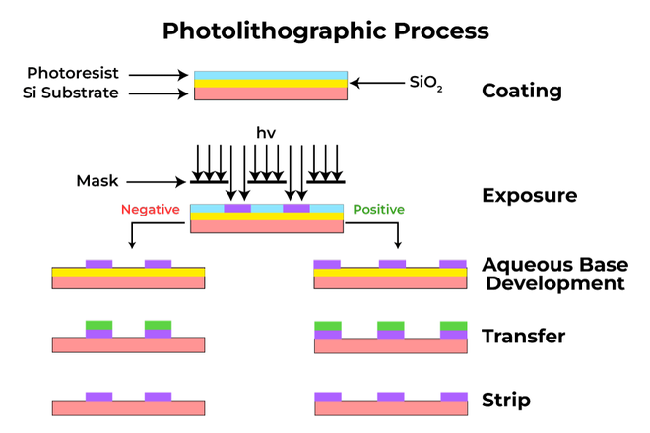

2.5 Etching.
Etching in integrated circuit (IC) fabrication is a process that uses chemical or physical methods to selectively remove unwanted material from a silicon wafer, creating the intricate patterns of a circuit. The two main methods are wet etching, which uses liquid chemicals to remove material isotropically (all directions), and dry etching, which uses reactive gases in a plasma to perform more directional (anisotropic) etching. Dry etching is often preferred for modern, high-resolution chips because it provides greater precision and control.
Wet etching
- Process: Wafers are immersed in liquid chemical baths that dissolve and remove unprotected layers of material.
- Etchants: Specific chemicals are used for different materials, such as hydrofluoric (HF) acid for silicon dioxide (SiO₂)or phosphoric acid for aluminum (Al).
- Etching profile: Typically isotropic, meaning it etches in all directions, which can lead to an "undercut" beneath the protective photoresist layer.
- Advantages: Simpler and less expensive.
- Disadvantages: Less precise and cannot achieve the high resolution required for modern, dense circuits.
Dry etching
- Process: Uses a plasma, generated from a gas, to chemically or physically remove material.
- Types:
  - Physical etching: Uses inert ions (like argon) to physically bombard and dislodge material from the surface, a process called sputtering. This is anisotropic but has poor selectivity.
  - Chemical/Reactive-ion etching (RIE): Uses reactive gases in a plasma. Ions are accelerated and bombard the surface, while the reactive radicals etch the exposed areas.
- Etching profile: Primarily anisotropic, meaning it etches primarily in one direction (downwards), which is crucial for creating sharp, vertical features and the high aspect ratios needed for modern 3D structures like FinFETs.
- Advantages: More precise, higher resolution, and better process control, making it essential for modern, high-density chips.
- Disadvantages: More complex and can have a higher risk of damaging the wafer from RF radiation.
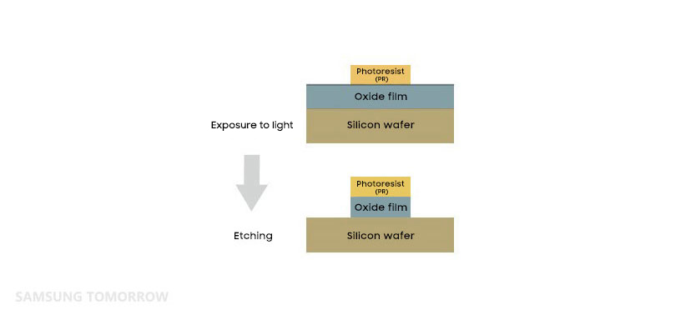

2.6 Doping (Diffusion and Ion implantation)
Doping is a crucial process in integrated circuit (IC) fabrication that introduces impurities, or dopants, into a semiconductor to alter its conductivity. Diffusion and ion implantation are the two primary methods for doping. Diffusion uses high-temperature furnaces to drive dopant atoms into the silicon, resulting in a concentration profile that decreases from the surface. Ion implantation, in contrast, uses an electric field to accelerate dopant ions and shoot them into the wafer, allowing for precise control over the depth and dose, but requires a subsequent annealing step to repair lattice damage and activate the dopants.
Diffusion
- Process: Dopant atoms are introduced from a gas phase or a doped oxide source and are moved into the silicon by high temperatures.
- Concentration profile: The concentration of dopants decreases monotonically from the surface, and the distribution is controlled by temperature and time.
- Types: It involves two phases: predeposition (introducing dopants to the surface) and drive-in (moving the dopants deeper into the substrate).
- Key characteristics: It is a high-temperature process, and dopants can only be introduced from the surface.
Ion implantation
- Process: Ions of dopant atoms are accelerated to high energies and embedded into the silicon wafer's surface.
- Concentration profile: Allows for precise control over the dose and depth of the dopant profile by adjusting the accelerating voltage.
- Key characteristics:
  - It is a lower-temperature process compared to diffusion, reducing physical defects.
  - Requires a post-implantation annealing step to repair lattice damage and electrically activate the dopants.
  - Provides greater control over dopant uniformity and can be used to form shallower junctions.
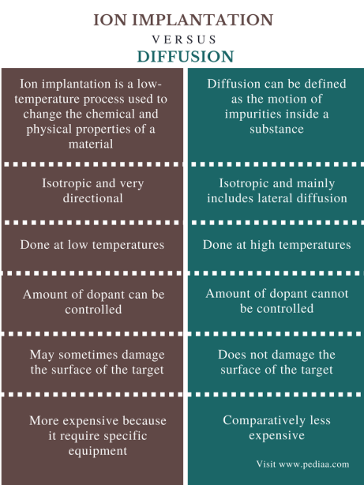

  - Deposition

Deposition in integrated circuit (IC) fabrication is the critical process of adding thin films of materials, such as insulators, conductors, or semiconductors, to a wafer's surface to build the intricate, multi-layered circuits. Key methods include Chemical Vapor Deposition (CVD) and Physical Vapor Deposition (PVD), which create films through chemical reactions or physical processes like sputtering, respectively. More advanced techniques, such as Atomic Layer Deposition (ALD), offer even greater precision for building these layers.
Key deposition methods
- Chemical Vapor Deposition (CVD): Involves a chemical reaction of a gas mixture on the heated substrate surface to form a solid material.
  - Plasma-Enhanced CVD (PECVD): A variation that uses radio frequencies to enhance the chemical reaction instead of high temperatures, which is useful for materials sensitive to heat.
- Physical Vapor Deposition (PVD): Uses a physical process, such as sputtering, to deposit material.
  - In sputtering, high-energy gas ions bombard a "target" material, ejecting atoms or molecules that then travel to and deposit on the wafer.
- Atomic Layer Deposition (ALD): A highly precise technique that builds films one atomic layer at a time.
  - It is a subset of CVD that uses alternating pulses of gases, providing exceptional control over thickness and uniformity

  - Metallization and Packaging

Metallization connects components on a chip with thin metal layers, while packaging is the process of cutting the wafer into individual chips, placing them into a protective package, and creating external connections. Metallization is a key part of the wafer processing sequence, using techniques like sputtering to deposit conductive pathways and bonding pads. Packaging then takes the completed wafer, dicing it into separate chips, and physically securing them within a protective housing with wire leads for external connections.
Metallization
- What it is: The process of depositing thin layers of metal to create the electrical connections (interconnects, gates, and contacts) between the components on a silicon wafer.
- How it works:
  - A thin layer of metal, most commonly aluminium or copper, is deposited over the entire wafer.
  - The metal layer is then patterned through a series of steps (like masking and etching) to create the desired circuit pathways.
  - This process is repeated to create multiple levels of interconnections.
- Purpose: To provide a conductive pattern that links the various components on the chip and to create "bonding pads" for external connections.

Packaging
- What it is: The final assembly stage where the individual, functional chips are separated from the wafer and placed into a protective package.
- How it works:
  - A diamond saw is used to cut the wafer into individual chips, called dies.
  - Each good die is then inspected and fixed securely into a package.
  - Wire bonds are used to connect the chip's bonding pads to the package's external leads, allowing the chip to be connected to a circuit board.
- Purpose: To protect the delicate chip from the environment (moisture, dust, physical damage) and to provide a means for connecting it to other components in a larger electronic system.

3. OPERATIONAL AMPLIFIER (OP-AMP.)
3.1 Introduction
- Operational Amplifier (Op-amp) is a very high voltage gain, DC coupled Differential amplifier.
- It is basically an integrated circuit (IC).
- Op-amp can amplify a weak signal as well as it can implement various mathematical operations like addition, subtraction, comparisons, log/antilog values, integration, differentiation etc, so that known as Operational Amplifier.
- The Basic building block of Op-amp is a “Differential amplifier”.
- The most commonly used op-amp is IC741 having 8 pins.
3.2 IC 741 PIN CONFIGURATION
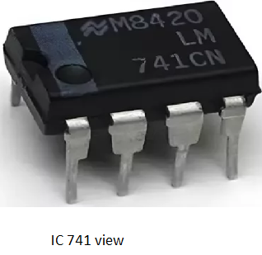
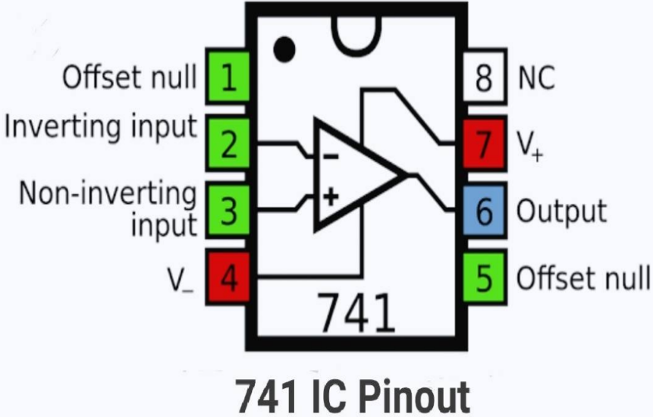
Fig 3.1: IC 741 & its Pin diagram
3.2 Op-amp symbol
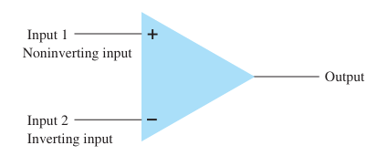
Fig 3.2 IC 741 symbol
3.3 Op-amp Configurations
- Open loop (no feedback)
- Closed loop (with feedback)
3.3.1 Open loop configurations:
- Single ended input
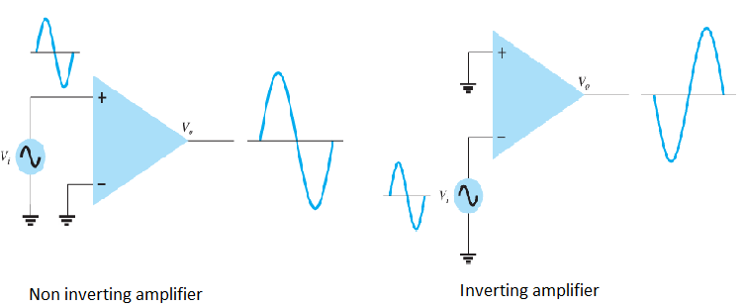
- Double ended (Differential) input
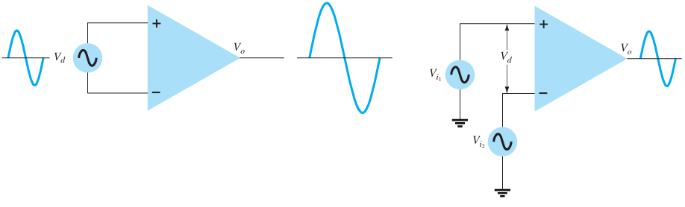
- Double ended output
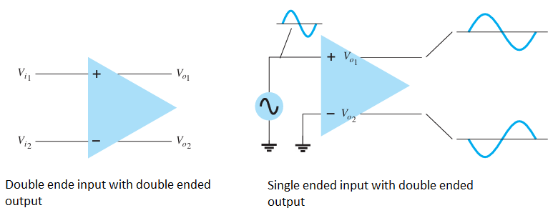
- Common mode operation
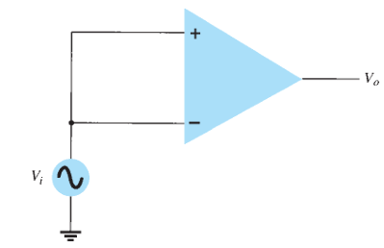
Fig 3.3 Open loop congigurations
3.4 Ideal Characteristics of an Op-amp/Characteristics of an ideal op-amp
- Voltage gain (open loop) = ∞ (practical value around 200000).
- Input impedance= ∞ (practical value 10¹² ohms)
(zero input current).
- Output impedance = 0 (practical value few ohms to several tens of ohms).
- Frequency Bandwidth=∞ (Practical value 1 MHZ).
- Common mode rejection ratio(CMRR)=∞ (Practical value 80Db).
- Slew rate= ∞ (practical value few V/µS.
- Offset voltage=0 (practical value few Mv).
- Power supply rejection ratio=0.
3.5 Definitions of CMRR, Slew- rate and Offset voltage:
- CMRR (Common mode rejection ratio): It is an ability of an op-amp to reject common mode input or noise. CMRR= A_{d}/A_{C}
CMRR(Db)=20log (A_{d}/A_{c})
- Slew rate: The maximum rate of change of output voltage of an op-amp with respect to time is called slew rate. Unit of slew rate is V/µS.
- Offset Voltage: It is the differential input voltage that would have to be applied to force the op-amp’s output to zero volts.
3.6 Closed loop Configurations:
For better stability and less distortion of the op-amp’s output, closed loop configurations are used. In the closed loop configurations, Negative feedback is used for amplifier circuits. On the other hand, positive feedback is used for Oscillators.
    - Inverting amplifier
Circuit diagram:
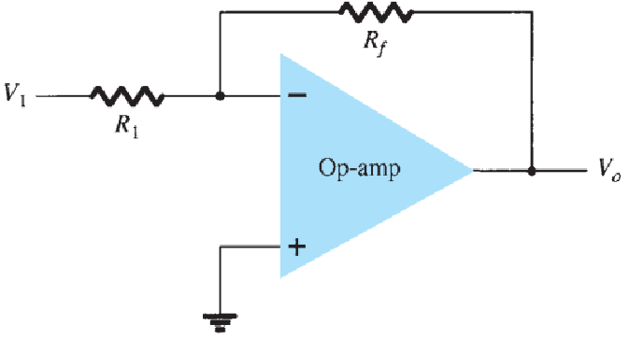
Fig 3.4 Inverting amplifier (closed loop)
Equivalent circuit:
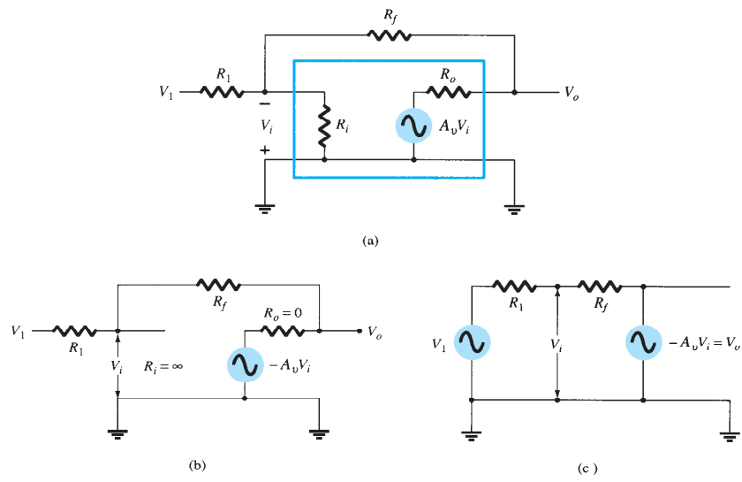
Fig 3.5 Equivalent circuits of inverting amplifier
Expression of voltage gain:
The total voltage v_{i,} 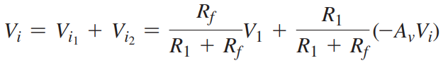 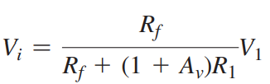
_{If AV >>1 and AV R 1 >>Rf ,}
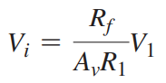
_{Solving for Vo/Vi,}
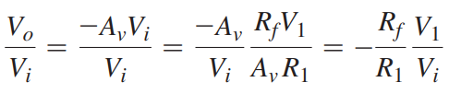
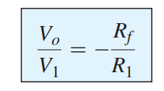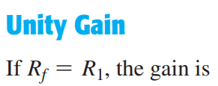
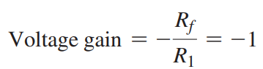

    - Non-Inverting amplifier:
Circuit diagram:
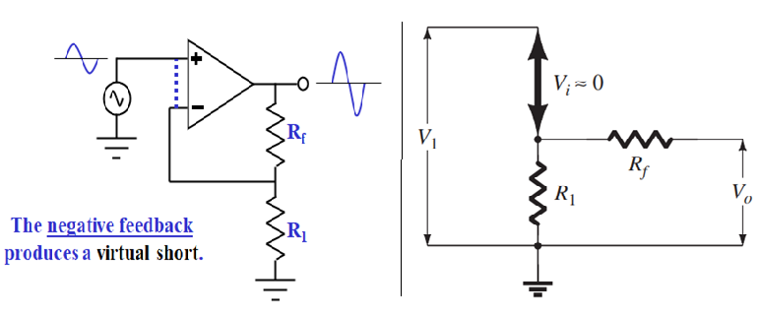
Fig 3.6 Non inverting amplifier
Expression of voltage gain:
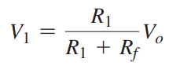
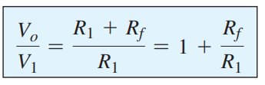
Unity voltage gain NI Amplifier:
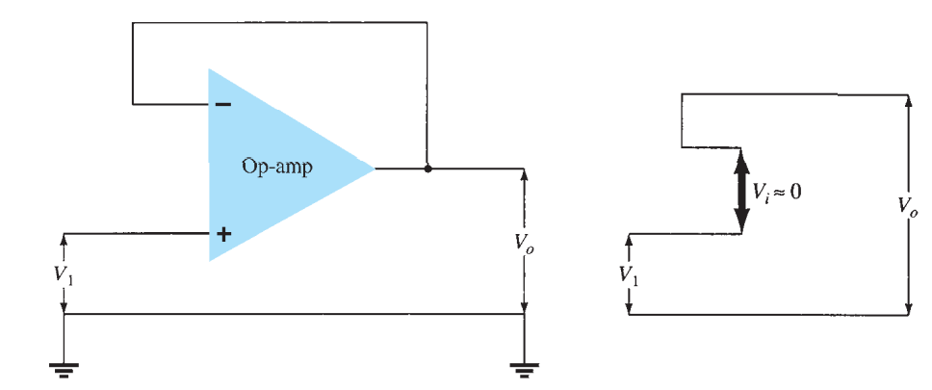
Fig 3.7 Unity gain non inverting amplifier (voltage follower)

- Timer IC 555

(What is an IC-555 chip and why is it important in electronics?/Need)
4.1 Introduction and Features
The 555 timer IC is an integral part of electronics especially projects, be it a simple project involving a single 8-bit Micro-controller and some peripherals or a complex one involving system on chips (SoCs), its working is involved.
It was introduced in 1971 by the American company Signetics in the original bipolar and low-power CMOS types. The widespread use of this timer is due to its low price, ease of use and stability.
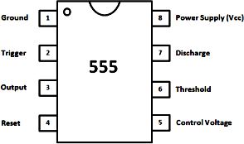
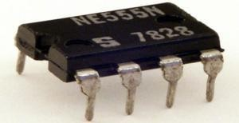
4.2 Pin configuration
Fig-4.1 Pin Configuration of Timer IC 555
4.3 Modes of Timer IC 555

IC- 555(Timer) has the following operating modes:
- Monostable (one-shot) mode
- Astable (free-running) mode
- Bistable (flip-flop) mode
- Schmitt Trigger (inverter) mode
4.3.1 Monostable Mode (Multivibrator)
In the monostable mode, as the name suggests, it stays in its stable state until and unless an external trigger is applied. The 555 timer outputs a single pulse of current for a certain length of time, hence also referred to as a one-shot pulse generator.
Functional Diagram of Monostable Multivibrator
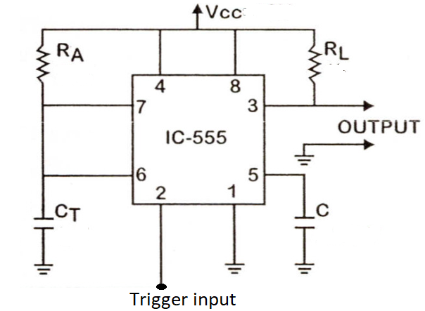
Fig-4.2: Circuit diagram of a Monostable Multivibrator
A monostable multivibrator has only one stable state. When a trigger input is applied, a pulse is produced at the output and returns back to the stable state after a time interval. The duration of time for which the pulse is high will depend on the timing circuit that comprises of a resistor (R) and a capacitor (C).
In the above figure the schematics for the basic mode of operation of IC 555 as a Monostable Multivibrator is provided. It requires only two extra components: a resistor and a capacitor along with the IC.
The details of the connection are as follows. The pins 1 and 8 are connected to ground and supply (VCC) respectively. Output is taken at pin 3. To avoid accidental reset of the circuit, pin 4 is connected to the VCC. Pin 5, which is the control voltage input, should be grounded when not in use. To filter the noise, it is connected to the ground via a small capacitor of capacitance 0.01µF.
Working of Monostable Multivibrator (Operation)
The sequence of events starts when a negative going trigger pulse is applied to the trigger comparator. When this trigger comparator senses the short negative going trigger pulse to be just below the reference voltage (1/3 VCC), the device triggers and the output go HIGH. The discharge transistor is turned OFF and the capacitor C that is externally connected to its collector will start charging to the max value through the resistor R. The HIGH output pulse ends when the charge on the capacitor reaches 2/3 VCC.
The internal connection of the IC 555 in monostable mode along with the RC timing circuit is shown below.
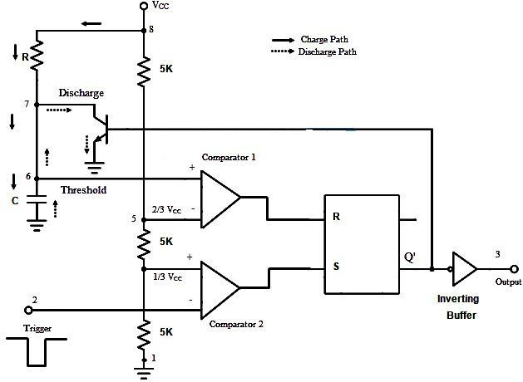

Fig 4.3 Internal diagram of Monostable multivibrator

Step-1:Initially, the flip-flop is RESET. This will allow the discharge transistor to go to saturation. The capacitor C, which is connected to the open collector of the transistor, is provided with a discharge path. Hence the capacitor discharges completely and the voltage across it is 0. The output at pin 3 is low (0).
Step-2:When a negative going trigger pulse input is applied to the trigger comparator (comparator 2), it is compared with a reference voltage of 1/3 VCC. The output remains low until the trigger input is greater than the reference voltage. The moment trigger voltage goes below 1/3 VCC, the output of comparator goes high and this will SET the flip-flop. Hence the output at pin 3 will become high.
Step-3: At the same time, the discharge transistor is turned OFF and the capacitor C will begin to charge and the voltage across it rises exponentially. This is nothing but the threshold voltage at pin 6. This is given to the comparator 1 along with a reference voltage of 2/3 VCC. The output at pin 3 will remain HIGH until the voltage across the capacitor reaches 2/3 VCC.
The instance at which the threshold voltage (the voltage across the capacitor) becomes more than the reference voltage, the output of the comparator 1 goes high. This will RESET the flip-flop and hence the output at pin 3 will fall to low (logic 0) i.e. the output returns to its stable state. As the output is low, the discharge transistor is driven to saturation and the capacitor will completely discharge.
It can be noted that the output at pin 3 is low at start, when the trigger becomes less than 1/3 VCC the output at pin 3 goes high and when the threshold voltage is greater than 2/3 VCC the output becomes low until the occurrence of next trigger pulse. A rectangular pulse is produced at the output. The time for which the output stays high or the width of the rectangular pulse is controlled by the timing circuit i.e. the charging time of the capacitor which depends on the time constant RC.
Waveforms:
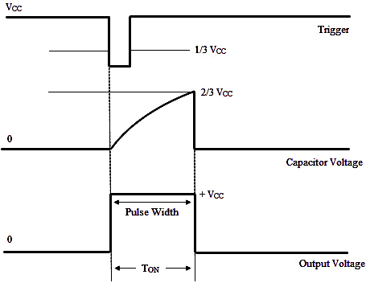
The waveforms of the monostable operation are shown below
Fig 4.4 Waveforms of IC 555 during monostable mode

Derivation
The voltage across the capacitor C rises exponentially. Hence the equation for the capacitor voltage VC can be written as
VC = VCC (1 – e-t/RC)
When the capacitor voltage is, 2/3 VCC, then
2/3 VCC = VCC (1 – e^{-t/RC})
2/3 = 1 – e^{-t/RC}
t= 1.098RC
Therefore, t ≈ 1.1 RC
The pulse width of the output rectangular pulse is W = 1.1 RC.
4.3.2 Astable multivibrator
Circuit Diagram:
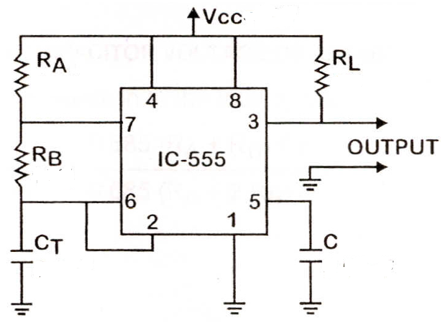
Fig4.Astable multivibrator
These circuits are not stable in any state and switch outputs after predetermined time periods. The result of this is that the output is a continuous square/rectangular wave with the properties depending on values of external resistors and capacitors. Thus, while designing these circuits following parameters need to be determined:
1. Frequency (or the time period) of the wave.
2. The duty cycle of the wave.
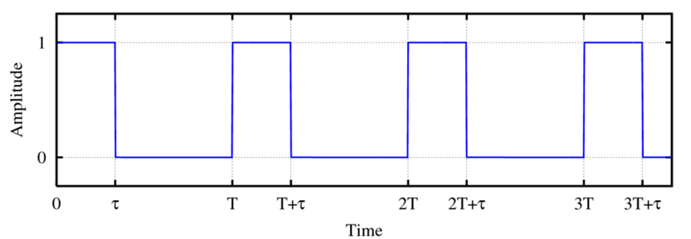
Fig 4.6 Rectangular waveform
Working:
- Referring to the above figure of a rectangular waveform, the time period of the pulse is defined as T and duration of the pulse (ON time) is τ. Duty cycle can be defined as the on time/time Period that is, τ/T in the above figure. Obviously, a duty cycle of 50% will yield a square wave.
- The key external component of the astable timer is the capacitor. An astable multivibrator can be designed as shown in the circuit diagram using IC 555, for a duty cycle of more than 50%. The corresponding voltage across the capacitor and voltage at output is also shown.
- The astable function is achieved by charging/discharging a capacitor through resistors connected, respectively, either to VCC or GND. Switching between the charging and discharging modes is handled by resistor divider R1-R3, two Comparators, and an RS Flip-Flop in IC 555. The upper or lower comparator simply generates a positive pulse if VC goes above 2/3 VCC or below 1/3 VCC. And these positive pulses either SET or RESET the Q output.
The time for charging C from 1/3 to 2/3 Vcc,
i.e, ON Time = 0.693 (RA + RB). C
The time for discharging C from 2/3 to 1/3 Vcc,
i.e. OFF Time = 0.693 RB. C
To get the total oscillation period, just add the two:
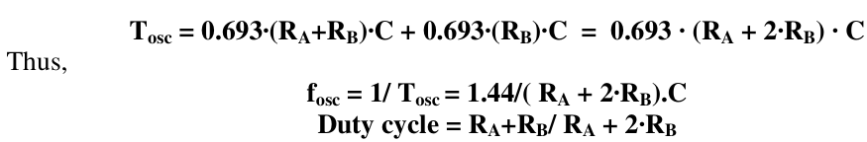
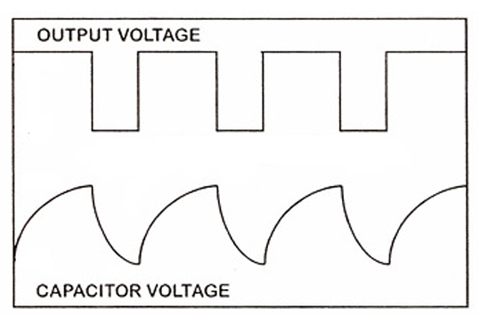
Fig 4.7 Waveform of astable multivibrator

